HUMAN RESOURCE AUDIT



**HR Audit :**

1. Definition Of HR Audit
2. HR Audit Significance
3. Need Of HR Audit
4. Scope Of HR Audit
5. Use Of HR Audit
6. Objectives Of HR Audit
7. Benefits Of HR Audit
8. Special Areas of HR Audit
9. Threats Of HRM

**10.** FIVE Approaches to HR Audit

**11**. Period of Audit, Audit Report

**Definition:**

An HR audit is a process to review the implementation of your institution's policies and procedures, ensure compliance with employment law, eliminate liabilities, implement best practices, and educate your managers.

(OR)

HR Audit refers to Examination & Evaluation of Policies, Practices & Procedures to detect Effectiveness & Efficiency of HRM and Verify if Mission, Objectives, Policies, Procedures, Programs are chased and expected results achieved. HR Audit also suggests future improvements based on past activities measurement.

**HR Audit Significance:**

Managements Feel, that Employee Participation in Activities is:

1. Essential for Organization success.
2. It Provides Required Feedback.
3. Managing Rising Labor Costs.
4. Increasing Opportunities for Competitive Advantage of HRM.
5. HR Audit can avoid Government intervention
6. HRP protect Employees interests

**Need for HR Audit:**

Though, to audit HR- Policies & Practices no legal obligation exists, some Modern Organizations chase too:

* 1. Increase the size of Organization & Personnel
  2. Change Philosophy of Management towards HR
  3. Increase Strength & Influence of Unions

**Scope of Audit:** HR Audi has a vid scope, involves much more than Management.

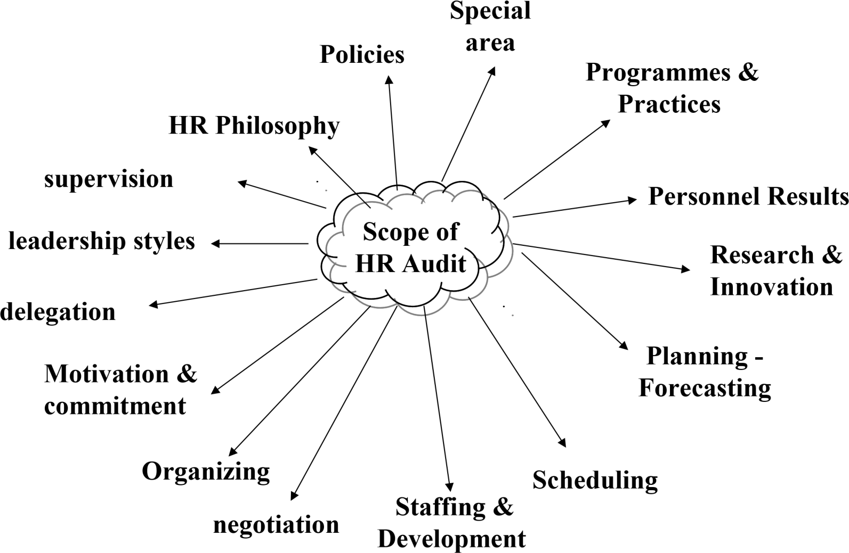

**Use Of HR Audit:**

The basic purpose of HR-Audit is to find:

1. How various units are **functioning**?
2. How they **met** policies & guidelines Pre-agreed upon?
3. To assist the Rest of the Organization in **locating gaps** between Objectives & Results.
4. Formulate a Plan for **corrections**

**Objectives:**

**1. Effectiveness:** To review the performance of the Human Resource Department and its activities to determine effectiveness.

**2.Implementation:** To locate gaps, lapses, failings in applying Policies, Procedures, Practices & HRdirectives. Also to see areas of wrong/ non-implementation that hindered the planned programs & activities.

**3.Rectification:** To take corrective steps to rectify mistakes, shortcomings contesting effective work performance of the HR Department.

**4.Evaluation**: To evaluate HR Staff & employees.**5.** To evaluate the extent to which Line Managers Applied Policies Programmes & Directives initiated by Top Management & HR Department.

**6.Modify:** To review HR System and Modify to meet challenges in comparison with other organizations.

**7.Questioning:** To seek answers to ‘What, Why ‘When Happened while implementing Policies, Practices & Directives in managing HRs.

**Benefits of HR Audit:**

1. Identifies contribution of HR Department.
2. Improves HR Department’s Professional Image.
3. Fosters greater Responsibility & Professionalism amongst HR Staff.
4. Classifies the HR Department’s Responsibilities & Duties.
5. Stimulates Uniformity of Personnel Policies & Practices.
6. Identifies Critical personnel problems.
7. Ensures Timely Legal Compliance Requirements.
8. Reduces HR Costs

**Pitfalls of HR Audit:**

* + 1. A full audit may be time-consuming.
    2. It May was not as objective and impartial as desired.

3.Impact of certain actions may not be clear.

**Special Areas Of HR Audit:**

**Audit of HR Function Audit of**

**Managerial Compliance**

**1.Employee Turnover**

**2.Absenteeism**

**Audit of HR Climate**

**3.Safety Records**

**4. Attitude Surveys**

**Audit of Corporate Strategy**

**Audit and Human Resource ResearcH**

**Audit of HR Function:**

Involves all activities of HR Functions, From HRP to IR Major Areas:

* + - * 1. Planning - Forecasting,
        2. Scheduling;
        3. Staffing & Development,
        4. Organizing;
        5. Motivation & commitment ;
        6. Administration ;
        7. Research & Innovation.

**Auditor’s Role:**

For each activity in the HR Audit functions Auditors must:

* 1. Determine the objective of the activity.
  2. Identify who is responsible for its performance.
  3. Review the performance.
  4. Develop an action plan to correct the deviation, between Results & Goal.
  5. Follow up an action plan. HR Evaluation must justify the existence of the department & its expenses. Department has no reason to function if fails to contribute to the Company’s bottom-line, Prune expenses to make department viable.

**FIVE Approaches to HR Audit:**

Auditors may choose any of the five approaches for Evaluation.

* + - 1. **Comparative Approach.**
      2. **Outside Authority Approach.**
      3. **Statistical Approach.**
      4. **Compliance Approach.**
      5. **MBO Approach**

**Comparative Approach –**

Auditors Identify another Company as a MODEL. Result of their Organization compared with those of Model Company.

**Outside Authority Approach –**

Often, Auditors use the standard set by Outside Consultant as BENCHMARK for comparison of own Results.

**Compliance Approach** **–**

Auditors review Past Actions to determine if those activities comply with legal requirements and Company Policies, & Procedures. A Final approach is for

Specialists & Operating Managers to set objectives in their areas of responsibility.

# Management By Objectives Approach –

Creates Specific Goals against which performance can be measured. Then the

Audit Team Researches **ACTUAL PERFORMANCE** and **COMPARES WITH THE OBJECTIVES.**

# PERIOD OF AUDIT

Naturally, any audit will be done annually. Though it is preferred to conduct a Human Resource Audit annually, it is advisable to conduct an audit once in three years or five years, keeping in view the fact that the realization of the Organizational goals may not be identified within a year.

# Audit Report

The Prog comes to end with the preparation of the Report. The report may be Clean or Qualified. It is Qualified if HR Performance contains Gaps for which remedies are suggested. The report is Clean where Performance is fairly Satisfactory

# Acknowledgment

I would like to express my special thanks of gratitude to my teacher Mrs. Nirmala as well as our principal Dr. M.S. Khatri who gave me the golden opportunity to do this wonderful project on the topic of Human Resource Audit, which also helped me in doing a lot of research and I came to know about so many new things I am thankful to them.

Secondly, I would also like to thank my parents and friends who helped me a lot in finalizing this project within the limited time frame.

# Declaration

I Rahul Singh Kathait hereby declare that my report writing entitled “Human Resource

Audit” is my original research work. It is submitted to Maharshi Dayanand University,

Rohtak, as a part of fulfillment for the session. I further declare that to the best of my knowledge this work has not been submitted to any other university or institution.

***Date: 17 Jan 2021 Rahul singh kathait***

***BCom Hons***

***Certificate***

This is to certify that the content of this project entitled “**Corporate and Environmental Sustainability**” by Rahul Singh Kathait is the bona fide work of his submitted to **N.B.G.S.M. College, Sohna** for consideration in partial fulfilment of the requirement of **Maharshi Dayanand University, Rohtak** for the award of BCom Hons. Degree.

The study concerned is carried out by him under my supervision in the academic year 2020-21. On the basis of the declaration made by him I recommend this project report for evaluation.

*Certified By:*

***Mrs. Nirmala***